SAVEETHA SCHOOL OF ENGINEERING
SAVEETHA INSTITUTE OF MEDICAL AND TECHNICAL SCIENCES
INSTITUTE OF CSE
CSA15- CLOUD COMPUTING AND BIG DATA ANALYTICS
LIST OF EXPERIMENTS
4. Create a simple cloud software application for Library book reservation system for
SIMATS library using any Cloud Service Provider to demonstrate SaaS include the
necessary fields such as Title of the book, author, publications, Year, edition, no of
copies, Rack no, status (taken/returned) etc.
INPUT:
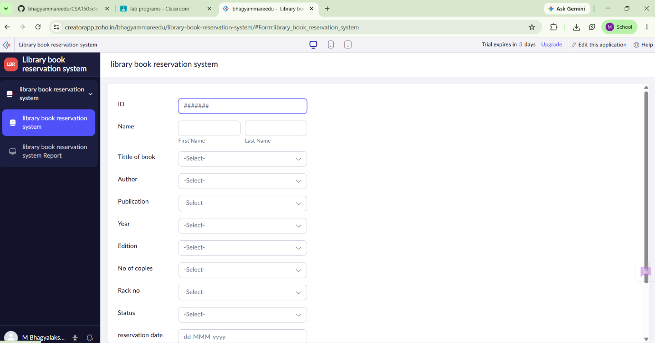

OVERVIEW:
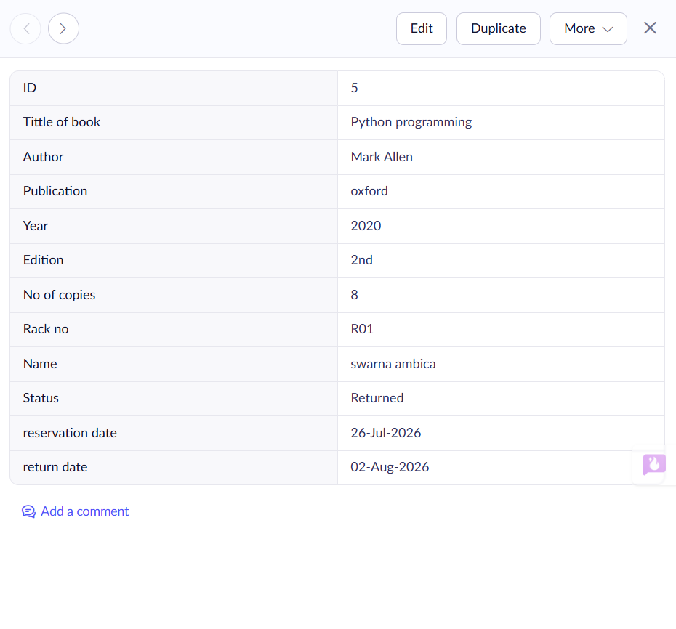OUT PUT:
